**Where Does Podcasting Go Next?**A manifesto for growth

[Go to the profile of Tom Webster](https://medium.com/@webby2001) [Tom Webster](https://medium.com/@webby2001) Aug 2, 2018

This is a long article. It will be challenging to some, especially those that have been in podcasting a long time (which, for the record, I have). I’ll make a deal with you, however — I’ll back up every assertion in this post with credible research data. You, in return, keep an open mind. Deal?

Last week I gave an opening keynote at [Podcast Movement](http://www.podcastmovement.com/), which has become one of the most important events in podcasting. In my talk, I took stock of where we are in the medium, where we need to go, and what we need to do to get there. I suspect some of what I had to say raised some eyebrows, but the issues that I mentioned *need* to be grappled with. So, I’d like to share those issues here with you, and I welcome your constructive dialogue.

My company, [Edison Research](http://www.edisonresearch.com/), first became involved in podcasting back in 2005, when I pushed to get the medium included on Edison’s annual flagship media study [The Infinite Dial](http://www.edisonresearch.com/infinite-dial-2018/) (which we publish every year with our partners at [Triton Digital](http://www.tritondigital.com/)). We announced our first data on podcast consumption in 2006 — it was basically a rounding error then — but we believed it would continue to grow.

Since then, it has grown, pretty steadily year over year, in several important ways. First of all, we have tracked awareness of the term “Podcasting” for over a decade. It was flat for several years, but since 2015 it has risen 15 percentage points, and is nearing two-thirds of the U.S. population for those 12 years old and up. People will often point to this graph as a kind of validation of podcasting, but (as I always point out on the annual Infinite Dial webinar) this only means that 64% of the country is familiar with the term. They’ve heard it mentioned — maybe on the radio, maybe by a friend. However, it does not mean that 64% of the country *actually knows what a podcast is*. Indeed, I can assure you that millions of these people do not, and I’m going to set down the proof of that assertion in a moment.

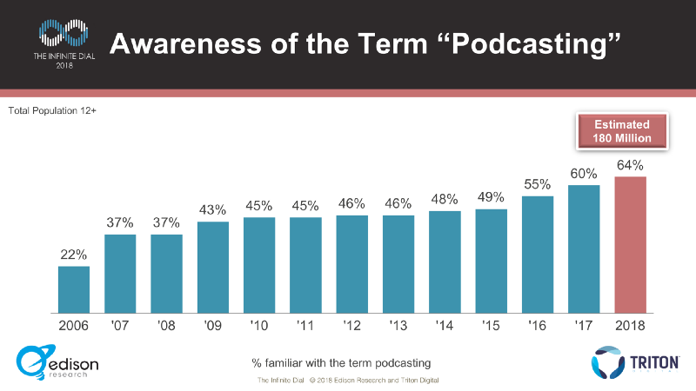

At this point, I think it’s necessary to stipulate something right up front: I have never advocated that we change the term “Podcasting” to something else, though some have colorfully misinterpreted my stance in that way. No, the name is what makes the medium special — if anything, I think we should double down on it! But let’s be honest about something:

Have you ever had to explain to someone what a podcast is?

Of course you have.

If podcasting is a medium (and I believe it is), then we have to do a better job explaining it to the general public. We haven’t done it yet.

Have you ever had to explain to someone what a *show* is?

Not to anyone over six years old.

Podcasting is the name. But it’s a name that requires explanation. We can agree on that, yes? Whenever I make this point, some will point out some other terms that required explanation, but stuck: VCR, DVD, Blu-Ray, etc. That they did. When was the last time you watched your VCR? Those terms are formats. Formats die. If podcasting is a medium (and I believe it is), then we have to do a better job explaining it to the general public. We haven’t done it yet. We may think we have because everyone we know, knows what a podcast is. Everyone you know probably has a podcast, for that matter. But I can assure you, millions of Clinton voters say they don’t know anyone who voted for Trump, and millions of Trump voters would say the opposite. We have to get out of our bubbles, and understand the real bottlenecks to the growth of podcasting, because it just isn’t growing that fast.

There. I said it. And it’s time to look at this graph and have an honest conversation about it:

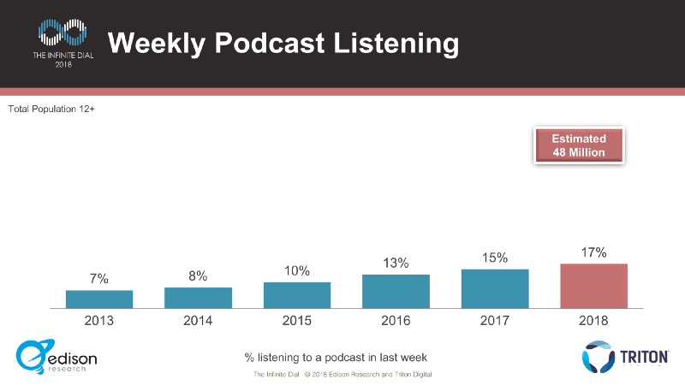

Since we started tracking podcasting in 2006, weekly consumption has gone from essentially zero to 17% of Americans aged 12+. That’s 0–17 in 13 years, or less than two percentage points per year. Now, it’s grown a bit faster over the past five years, but can anyone look at this graph and call podcasting a fast-growing medium? It’s actually one of the *slowest-growing* media we’ve ever tracked in The Infinite Dial.

The title of my Podcast Movement talk was “Podcasting’s Next Frontier: 100 Million Listeners.” And the 100 million I am talking about is weekly listeners — the graph above. Right now we are at 48 million weekly listeners. So, to get to 100, the medium has to more than double its number of weekly listeners. At the current rate, how long do you think that would take? Eight years? Ten? Longer?

I hope it doesn’t take longer. Listen, I’ve done some hard livin’ — I need this to pay off now. In any case, we need to step back and look at the last 13 years and admit something — it’s been a slow build, over a period of time when streaming music and video and social media and mobile have all grown muchfaster. The growth curve of streaming music online is nearly identical to the growth curve for smartphone penetration. Why doesn’t podcasting’s curve look anything like that?

And there is also this: some year we are going to release The Infinite Dial report and it’s going to show podcasting flat — or maybe even down. I’m sure back in 2006 executives at MySpace were busily projecting that they would soon surpass Geocities or even Altavista — but growth isn’t guaranteed. And someday, it stops, just as it did for Facebook and Twitter this year.

That’s the constructive conversation I’d like to have here. The cold, hard truth: 17% of Americans say they listen to a podcast at least once a week. 64% of Americans say they know the term. That means that about three quarters of the people who say they know the term “podcasting” are not weekly listeners. Do we think that is good? Great? Not great?

Here’s something I can tell you for a fact: millions of those people who say that they are familiar with the term podcasting, but have never listened to a podcast, do NOT understand what a podcast is. There are dozens of opinions and beliefs out there about the nature of podcasting, and if we are going to continue to grow the medium as its own distinct channel, we have to understand something:we are never going to ‘educate’ someone to become interested in something they aren’t interested in.Some of the beliefs people have about podcasting are misconceptions, to be sure — but some of them aren’t.

**Got Podcasts?**

I once believed that podcasting required its own “Got Milk” campaign — a concerted effort by the industry to explain exactly what a podcast is, how you would listen to it, and where you could find them. I don’t believe that anymore — or at least, I don’t think it solves the real underlying problem. To grow the medium from its current 48 million weekly listeners (in America) to 100 million listeners means converting 52,000,000 — or, as I will call them**,**The 52**.** To believe that The 52 will convert once we explain podcasting to them is to assume that The 52 are similar to the 48 we already have — that what got us here, is going to get us there.

I can assure you that The 52 are different people than the existing audience for podcasting. The 52 don’t need podcasting explained to them. They need a reason to care.

The fact is, we are lousy with ways to listen to podcasts, but not lousy with reasons to do so.

At the beginning of this piece, I promised you some research data, and here it is. My colleagues and I at Edison set out to understand The 52 — especially those millions of Americans who say that they are familiar with podcasting, but have never listened to one. We did this first with a series of qualitative interviews with people who fit those criteria exactly — familiar, but have never listened — to get a sense of what their perceptions of the medium are.

So, first — I’d like to introduce you to some of the “nevers.” I hope you watch this, because these are truly representative of millions of The 52:

So how much of this is true? I mean, these people were very compelling, but are they representative of any of The 52? How many people really have these various perceptions?

To find out, we conducted an online survey of 1,000 Americans 18+, all of whom told us they were familiar with the term “podcasting.” We weighted that data to The Infinite Dial data set for 2018, and we asked those people when, if ever, they last listened to a podcast. We set aside those who told us they’d listened to one in the last six months, and took a close look at those who say they’ve never listened, as well as those who haven’t listened in over a year and those who listened in the last –12 months. The largest group by far of those three were the “never listens,” who were as large as the other two combined! So we had a great sample of The 52, and in particular, those who say they’ve heard the term, but never listened to a podcast.

**Podcasting Perceptions**

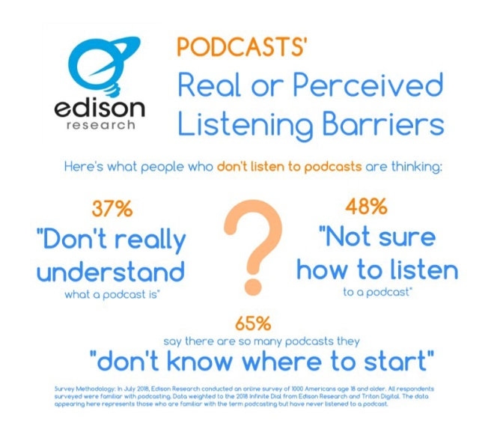

I’m going to come back to the stat at the bottom of this graphic later, but let’s quantify something right off the bat. 37% of the people who are familiar with the term “podcasting” but haven’t listened to one don’t really know what a podcast is. And you heard some of those misconceptions in our video, right? Here’s the thing — none of these people are wrong. They’ve had no reason to find out what a podcast really is because we haven’t really given them a reason to find out.

And by the way, that 37% is the percentage of the “nevers” who admit ignorance, which very likely means this number is a bit of an underestimate. In fact, I would submit that the second number, the 48% of the “nevers” who say they don’t know how to listen to a podcast, is probably the real percentage of the “nevers” who do not, in fact, know what a podcast is. After all, if you truly knew what a podcast was, you’d probably know how to listen to one.

Of course, one of the ways that people can listen to a podcast is with a dedicated app. When we asked the “nevers” if they had one, we got a fairly surprising result:

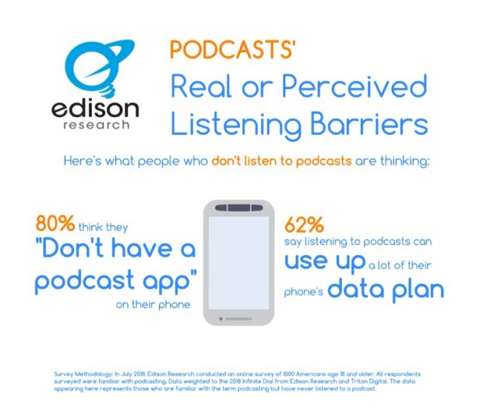

Eighty percent of the “nevers” say they don’t have a podcast app on their phone — and these are both Apple and Android users. Very few of them are correct, by the way. Not only do most people have a podcast app on their phone — most people have multiple podcast apps on their phone. If you don’t believe me, you need to expand your definition of podcast app to Google, Spotify, TuneIn, Pandora, iHeart, and many more apps that people already likely have on their mobile device. The fact is, we are lousy with ways to listen to podcasts, but not lousy with reasons to do so.

There were once was a time when plenty of people didn’t think they had a Netflix app, didn’t know they needed one, and weren’t sure how to watch it without getting discs emailed in those red envelopes. So what did Netflix do? They didn’t spend a bunch of money on a “Got Netflix?” campaign. They spent a lot of money on *Orange is the New Black*, and *House of Cards*. What gets people to discover Netflix is curiosity, and what drives curiosity is the show. The killer show. But we aren’t there yet, as the next two graphs will show you:

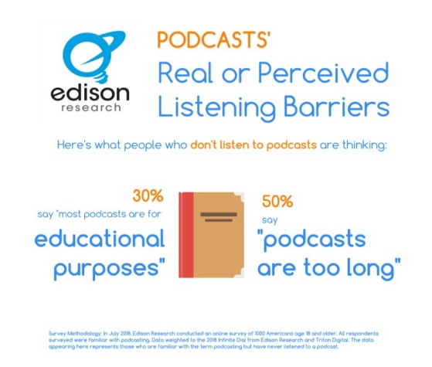

So here you see that nearly a third of the “nevers” think that most podcasts are for educational purposes. And you know what — they aren’t wrong, are they? Similarly, nearly half say podcasts are too long. Now, you will never hear me give you an ideal length for a podcast. I get that question weekly from journalists. I’ll never answer it because there is no single answer. There’s room for *Up First*, and there’s room for *Hardcore History*. Podcast hosts will tell you that many of the most popular podcasts are an hour or so — but that’s partially because many of the best podcasts TODAY happen to be an hour long. Again, what got us here won’t get us there. Shorter, daily podcasts are driving more podcast consumption, and what these data tell us is not that the ideal length for a podcast is short — it’s that many people don’t perceive that we have enough quality shorter content. People want options. And they don’t have them. [I’ve made this argument for years now,](http://brandsavant.com/brandsavant/the-five-hurdles-of-podcasting-and-why-googles-recent-move-is-only-the-first) and it’s still true — look at the top iTunes podcasts:

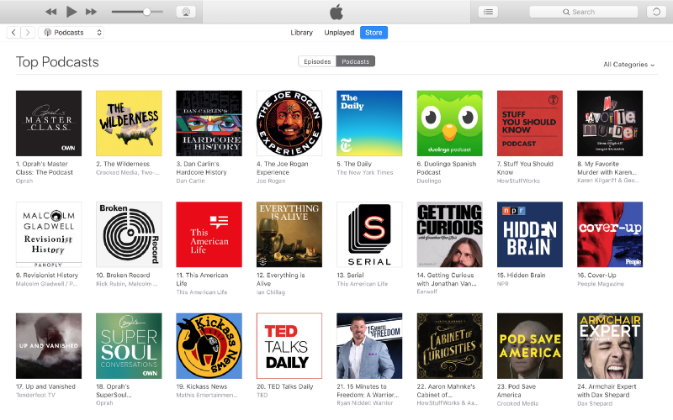

You see a lot of public media, a lot of highbrow content, and a lot of longer content. The 52 seem to have nailed this one! Now, look at the Nielsen top shows from a couple of weeks ago:

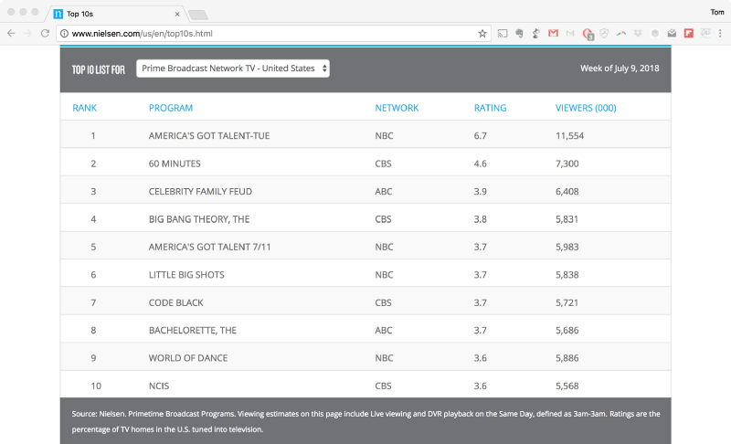

Nearly four years after I first wrote about this, these two charts still look nothing alike. Two of these shows are *America’s Got Talent*, and I don’t think we do! There’s *The Bachelorette*, and one of those acronym-cop shows that always seem to be in the top 10. The top show of the 2017–2018 TV season was *Roseanne*. In short, it’s crap — but it’s high quality crap.We need more high quality crap.Of course, there is a giant hole in content for podcasts, and its relative paucity is surely one of the biggest barriers to faster adoption. Of course, I am speaking about the most popular form of audio content in the world: Music.

This is absolutely one that the podcast industry has to fix. Right now, if you podcast licensed music, a music industry lawyer will shoot you in the face. According to Edison’s most recent [Share of Ear](http://www.shareofear.com/) data, 77% of time we spend listening to audio we spend listening to music — and that ratio is not going to move quickly, if at all. I recently keynoted the podcasting track at MusicBiz 2018, where I spoke about this issue before an audience of the people who, if not the actual shooters, are at least the ones that ordered the hit. The fact that they even had a podcasting track shows that the music industry is at least thinking about this — after all, every time you listen to a podcast on Spotify, you are not listening to a song, and they are not getting paid royalties.

So, there is some incentive on the part of the music industry to address the licensing challenges of music in podcasts. But podcasters need to push too. Music is a huge, relatively untapped focus area for podcasts, and one that The 52 in particular would certainly enjoy.

**Please Don’t Subscribe**

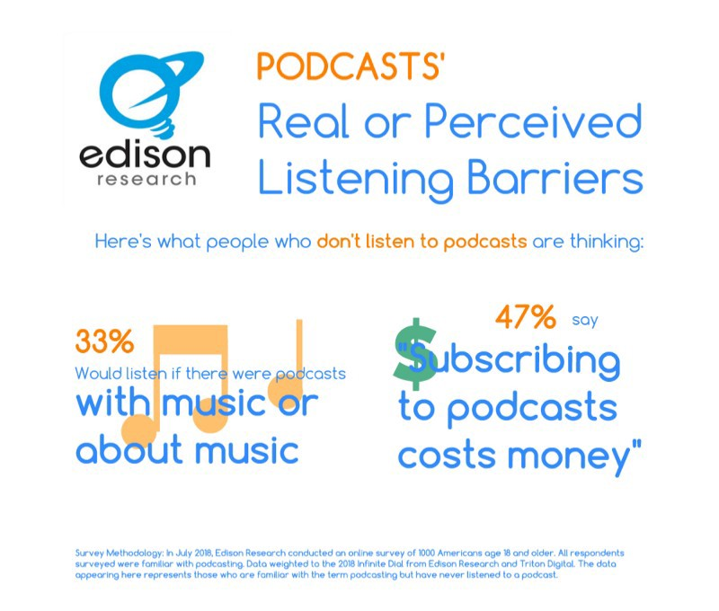

Now we are getting to one of the more dangerous perceptions — that podcasts cost money. This is a flat out misconception, but it’s one that *we* created with our continual insistence that people “subscribe” to our show. With the exception of a YouTube channel, you pay for things you subscribe to — magazines, satellite radio, HBO, the fruit-of-the-month club. The listeners we have may understand that podcasts are largely free. But many of The 52 do not.

Also, it’s kind of a big ask, no? Here’s what you don’t subscribe to…TV shows. Radio shows. Movies. Almost anything else we choose to watch or listen to. We ask for this incredible order. We don’t deserve to have our shows automatically delivered every week with a notification. *Westworld* doesn’t get that. You earn a listen. Week after week. Because Apple has accelerated the pace of “The Listen.” The download may be what we trade on now, but we all know that “The Listen” is the ultimate goal, and Apple’s analytics and the [RAD working group](https://adexchanger.com/digital-audio-radio/npr-pushing-podcast-industry-forward/) are all accelerating that dialogue. And when we get there, do you think you are going to want your show to have a bunch of unlistened-to downloads? Why would you have or want those? Also “Subscribe to us on iTunes, Stitcher, Google Play, or anywhere else you get your podcasts” is a cry for help. It’s a confusing, twisted call to action.

We need to give The 52 — the people we need to get to 100 million — a better on-ramp to podcasts. Your podcast needs a website. And the most obvious thing you need to be able to do when you get to that website is to listen to the show. Sure, have your subscribe buttons here — but maybe explain them. Or maybe change the language to “Follow my show to receive it free every week.” And let’s think about replacing “Subscribe to us on iTunes, Stitcher, Google Play, or anywhere else you get your podcasts” with “listen to my show at myshow.com.” Isn’t that better?

17% of Americans say they listen to a podcast at least once a week. 64% of Americans say they know the term.

I really believe things like this do more damage than good. You can insist that a podcast automatically be delivered via RSS enclosure all you want, but make sure you stock your compound with canned food and bottled water, and hunker down for the end timesmy friend. I’m interested in what gets us there. And I don’t care about what you say on your website — I’m talking about the audio of your show. If the audio call to action in your show is “Subscribe to us on iTunes, Stitcher, Google Play, or anywhere else you get your podcasts” then you are not reaching The 52.

Ultimately, there are more people out there with misconceptions about podcasting than there are regular listeners. And that’s really want I want to address in the last section — what I think the ultimate issue is, and what the marketing plan for podcasting needs to be to reach 100 million listeners as quickly as we can. And that’s this — if we have one thing to tell people about podcasting, what should it be? Let’s look at a few final graphs…

**Let’s Put On A Show, Kids**

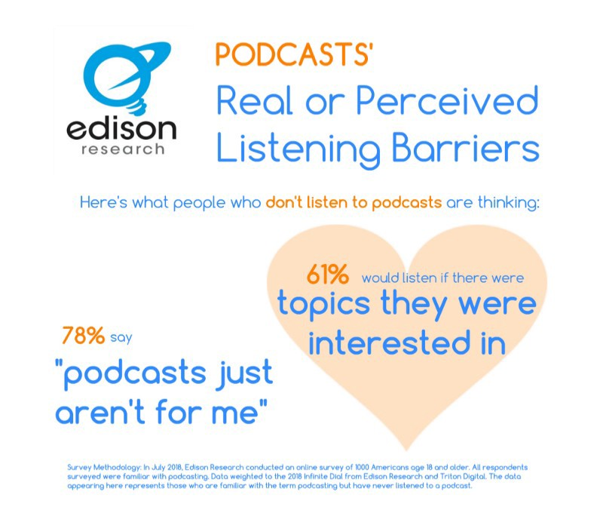

Now, I want to come back to a data point I presented earlier — the 65% of the “nevers” who agree that there are “so many podcasts you don’t know where to start.” If you read this as a discovery issue, you’ve read this wrong, friends. These aren’t people who already listen to podcasts. These are the people that have never listened to a podcast. The issue isn’t that there are too many — the issue is that there isn’t one. Here’s the simple truth — just as it was for HBO, Netflix, Hulu, and any other form of newonline media, the on-ramp is the show. And while we need to make listening to the show simpler — we also need a show. When people say that “Podcasts just aren’t for them” or that there aren’t topics that they are interested it — maybe we should take them at their word? They need a show — just one show — and we either haven’t led them to it yet, or maybe…just maybe…we haven’t made it yet.

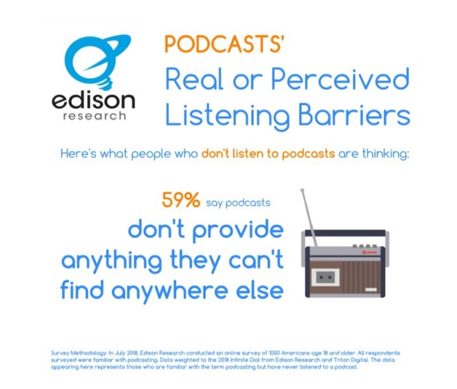

Commercial broadcast radio hasn’t helped with this perception, by the way. For years, AM/FM morning shows have been telling listeners that “if you missed [*Weenie and The Butt*](https://www.youtube.com/watch?v=_mcKzDwm8_o) this morning, just go to WQHG.com and download our podcast!” On the one hand, this has spread the name “podcasting” for us (but, as I mentioned earlier — awareness isn’t our problem.) On the other, in this context, it has taught millions of Americans that a podcast is just that: catch-up radio. Nothing special. And nothing that can’t be heard every day, on the radio. There is, however, a valuable lesson we can learn from commercial broadcast radio.

Earlier I mentioned that the final answer here is not a “Got Podcasting” campaign. I’ll tell you how I know this. Commercial AM/FM radio still has incredible reach in this country, but ad revenues are down, and media buyers are migrating more and more to digital. Commercial radio certainly has an image problem — and so for years, commercial broadcast executives have lamented what they consider the real problem — they aren’t telling their story as an industry well enough. But look, all the PR in the world can try to change your mind about the medium of AM/FM radio — but what would it say? That radio is the transmission and reception of electromagnetic waves of radio frequency, especially those carrying sound messages, and that you need this device to hear it, and here is how you operate that device? Absurd. It didn’t work, and it doesn’t work, because people don’t care. But give them *The Handmaid’s Tale*, and they’ll figure Hulu out right quick. Where commercial broadcast radio is underperforming is in marketing the show. Unfortunately for commercial radio, most stations are either playing music or syndicated programming. They don’t own a translatable show to market. It’s *Billy and The Beanbag* in the morning and classic hits all day long.

Now, we podcasters potentially have the show And the way to get podcasting to 100 million listeners is to put on a show, make it a great show, and market the show, not the medium. And a great show starts with a great idea. If someone asks you if you have a podcast, and what that podcast is about, what do you say? Do you say “It’s two regular guys talking about the Cubs?” Is that a show? Or is that the equivalent of eavesdropping on conversations at the bar at Lou Malnati’s? Or listening to a Hootie and the Blowfish cover band? Or watching *NYPD Blue* after David Caruso left? Two guys talking about sports is banter. [*Jalen and Jacoby*](http://www.espn.com/espnradio/podcast/archive/_/id/9545077) is a show. And a show starts with a great, unique idea. My friend and podcast partner [Mark Schaefer](http://www.businessesgrow.com/) calls this the “Only We” of a brand. The key to whether or not you have a show lies in your ability to complete this sentence: Only our podcast…

Answer that question for your show. What is the magic, big idea that gives your show its reason to earn that listen? Is it…we say funny things about the movies? Or is it “A futuristic western theme park turns to terror when the robot hosts begin killing guests”?

And once you have that big idea, the “Only We” of your podcast, then you owe it to your audience and to The 52 to produce it, to edit it, and to make it as compelling to listen to as you can, because you aren’t competing against the *Billy and The Beanbag* podcast. Not any more. The OG’s of podcasting were, and those things worked if you started in 2006. Today? The number one competition for your podcast isn’t another podcast. It’s Netflix. We need more high quality content out there, because The 52 demands high quality, broad concept content.

Once you have a show, you need to market that show. We need you to market your show! You need a simple message — the “Only We,” the big idea — and then you need that simple call to action: listen to my show at myshow.com. And you need to put that message in front of people. You don’t need to run digital outdoor in Times Square like Midroll’s great campaign. Social media can work, but honestly, I’m a big fan of doing offline things, locally where you are.

If you can get your show in front of 100 people in your city or town, those 100 people know 10,000 people. Soon, eleventy billion people are listening to your podcast. But you can’t eat the elephant all at once. There are so many cost-effective ways to reach 100 people. Be where people are: street fairs, food festivals, the mall! If you have a sports podcast, you should be posting placards above the urinals and behind the doors in the restrooms at sports bars. These things don’t cost muchand they work.

You can even advertise on other podcasts. Heck, my friend Kris Smith can put ads for your podcast onto other podcasts [with a credit card and a hundred bucks](http://knit.audio/). Start locally. If you have a simple concept, and a simple callto-action, and a great show, it isn’t rocket surgery. But to get The 52, we need to set the bar higher.

Once people discover the show, then you can make the bigger asks. Introduce them to what subscribing means, or ways that they can support the show. But not at the start. Remember, these are The 52: The people that you *haven’t*gotten doing things the way you are currently doing them. And you don’t have the right to them, you do not deserve them, and you aren’t naturally going to get them over time. You are going to have to earn them.

If we are dependent on educating people about the medium and how to use it, we are doomed to be a curiosity. But if we can build the show, give people the simplest, single on-ramp to the show, play them the show, and market the show, we’ll get The 52. I know we will. It works in every medium. And I’ll leave you with some proof:

My colleagues and I are proud to have served this industry for 14 years. And we’ll be around for the long haul. But let’s not wait too long. We’ve spent the early years of podcasting creating great shows that we are passionate about — often, creating the shows that *we* wanted to hear because they weren’t available elsewhere! But my challenge to you, to me, and to the entire medium we call podcasting is this: let’s make a show for them.